SUN

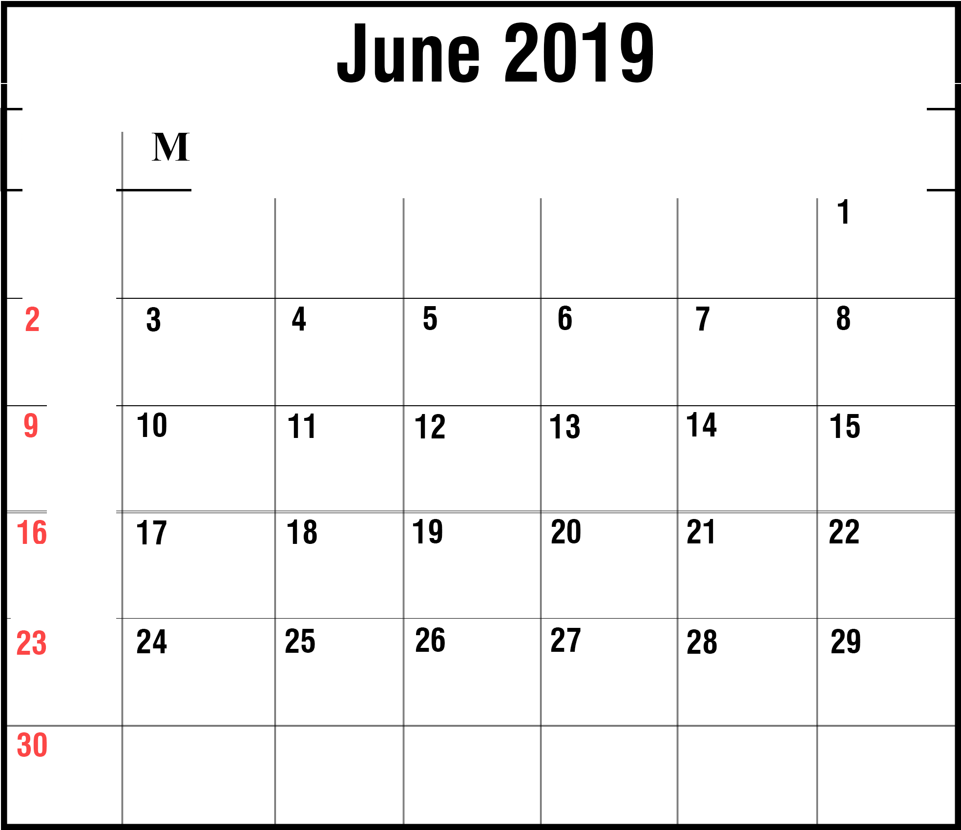

Father's Day

ON TUE ED THU FRI SAT



**Notes:**